Freshwater farm plan regulations
Summary of the discussion document

We are consulting on freshwater farm plan regulations
We are asking for your feedback on the proposed freshwater farm plan (FW-FP) system, the content of plans, how to transition to the system, and how plans will be implemented.
Engagement on regulations to support the freshwater farm plan system has begun. We are accepting submissions from 26 July to 12 September 2021. This document gives an overview of the topics we are consulting on.
This summary document provides a high level overview of the key system design choices being proposed in the discussion document and indicates preferred options at this stage (shown in the grey boxes).

Preparing freshwater farm plans
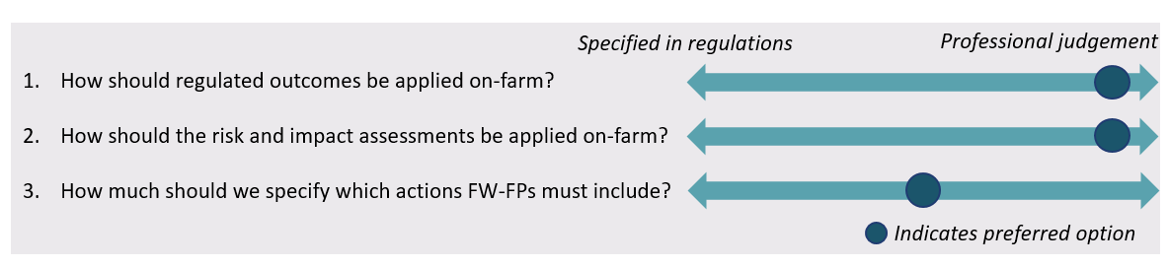
Freshwater farm plans will identify clear outcomes or goals to meet, not a set of rules to follow. The outcomes will apply to farm practice, ecosystem health and the wider catchment. The plans will need to demonstrate how the outcomes will be achieved. The plan will also include a risk and impact assessment and actions to address those risks or impacts.
The more the system relies on professional judgement when drafting freshwater farm plans, the more it relies on the competence of certifiers.

Design of the certification system
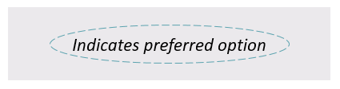
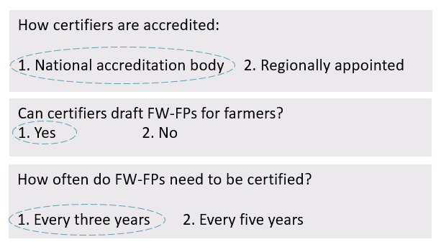
Freshwater farm plans will need to be certified by someone who is accredited to ensure the freshwater farm plan meets the requirements and is fit for purpose.

We also propose that:
- farmers engage and pay certifiers
- farmers get a new FW-FP if their land use, ownership or farming system changes
  - FW-FPs will require an addendum if the farming area changes, or new activities are started (but the farming system is largely unchanged)
  - FW-FPs will need to be amended if the farm operator or the farm owner changes.
- processes for disputes, complaints, and removing certifiers accreditation are introduced.

Design of the audit system
An auditor assesses whether the farm complies with the certified freshwater farm plan. The auditor reports their findings to the farmer and relevant council.
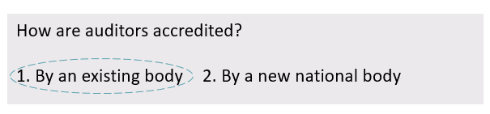
We also propose that:
- farmers engage and pay auditors
- FW-FPs be audited 18 months after certification and again up to 3 years later if they pass the audit or within 12 months if they fail the audit.

Roll out of freshwater farm plans
Freshwater farm plans will not be required across the country all at once and it will take time for every farm in New Zealand to have a certified freshwater farm plan. This is due to the resource needed from certifiers, auditors, advisors, and regional councils to implement the freshwater farm plan system.
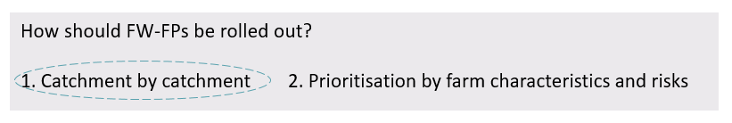

Embedding catchment context in freshwater farm plans
Regional councils will be responsible for supplying catchment context and partnering with tangata whenua. Individual farmers and growers will not have to engage tangata whenua in the development of their freshwater farm plan.

Proposed mandatory ‘base’ content for freshwater farm plans
Freshwater farm plans must include details on how outcomes are to be met, the risk assessment and any actions to avoid, remedy or mitigate the impact of activities on freshwater and freshwater ecosystems.
We also propose that freshwater farm plans should include other mandatory base content including:
- property and business details
- the nature of farming activities
- farm information and maps
- certification and audit details.
For data collection we propose that over time freshwater farm plans will be digital, not paper-based, to fit with regional council systems.
We are aware of privacy concerns when collecting farm data. We know this data needs to balance privacy, while allowing the effectiveness of the system to be evaluated. We are seeking your views on how to best protect privacy.
For public reporting we propose that:
- regional councils publicly report some information (to show progress of the freshwater farm plan system)
- this data be aggregated to protect farm operators’ privacy.

Preferred options for monitoring and enforcing freshwater farm plans
A quality assurance mechanism is a key part of the freshwater farm plan system. Its purpose is to ensure that certified freshwater farm plans are of an acceptable standard to achieve the intended freshwater outcomes. To do this we propose:
- a national FW-FP quality assurance mechanism, overseen by a national public entity, such as a Ministry or other Crown entity, in partnership with regional councils and tangata whenua representatives.
For enforcing freshwater farm plans we propose:
- that auditors report audit results to regional councils
- that regional councils use the enforcement tools in the RMA for non-compliance
- a series of infringement offences (ranging from $500 – $1500).

Have your say

We are accepting submissions online from 26 July until 12 September 2021. Read the full discussion document and have your say at https://consult.environment.govt.nz/.
For more information, contact freshwaterfarmplans@mfe.govt.nz.

Disclaimer
The information in this publication is, according to the Ministry for the Environment’s best efforts, accurate at the time of publication. The Ministry will make every reasonable effort to keep it current and accurate. However, users of this publication are advised that:
- The information does not alter the laws of New Zealand, other official guidelines, or requirements.
- It does not constitute legal advice, and users should take specific advice from qualified professionals before taking any action based on information in this publication.
- The Ministry does not accept any responsibility or liability whatsoever whether in contract, tort, equity, or otherwise for any action taken as a result of reading, or reliance placed on this publication because of having read any part, or all, of the information in this publication or for any error, or inadequacy, deficiency, flaw in, or omission from the information in this publication.
- All references to websites, organisations or people not within the Ministry are for convenience only and should not be taken as endorsement of those websites or information contained in those websites nor of organisations or people referred to.

Published in 2021 by the Ministry for the Environment and the Ministry for Primary Industries.
Publication number: INFO 1015

